Next Step
2021 Year 12 completers survey
Post-school destinations of Year 12 completers from 2020

Music Industry College

Introduction

This report is to inform the community about Year 12 completers’ transitions into further education, training and employment.

This information is useful for:
- reviewing programs and services, such as subject offerings, career advice and links with employers and tertiary institutions
- reporting to parents through newsletters, annual reports and the school website.
The results are from the Department of Education’s Next Step — Year 12 Completers survey. The survey is conducted six months after the end of each school year when students will have accepted tertiary education places. Students who completed Year 12 in 2020 at a state, Catholic or independent school, or TAFE secondary college in Queensland are included.

Post-school destinations are influenced by the transitioning environment, which can limit the options available to young people. Low response rates may not give an accurate summary of the cohort’s destinations.

Find out more
Visit the Next Step website www.qld.gov.au/nextstep for more information on the survey, view the statewide report or create a custom report using report builder, which will be updated in October 2021.

Survey response rate

75.0% (30 out of 40 Year 12 completers) Decreased by 15.0 percentage points since 2017.
Results may not be representative of all Year 12 completers from this school.

Response rate over time School's response rate compared with SA4 region and state

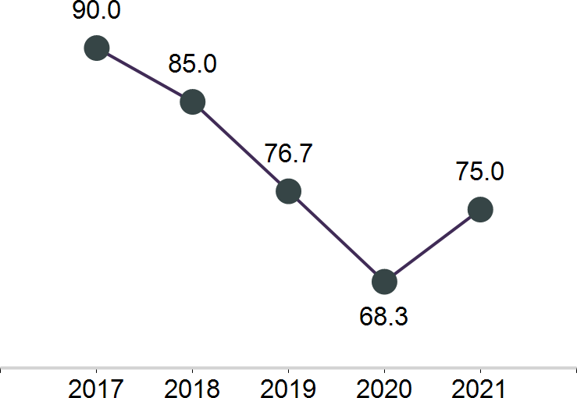

Post-school engagement

Year 12 completers from Music Industry College have been categorised by their engagement in education and training, or employment. Survey respondents who are both working and studying are included in education and training. Apprentices and trainees are required to undertake a study component to their qualification so are also considered to be in education and training.

Engagement in education, training or employment
73.3% engaged in education, training or employment

43.3%
in education or training

30.0%
in employment only

26.7% not in education, training or employment
Of the 30 respondents, 43.3% continued in some recognised form of education and training. The most common study destination was bachelor degree.

A further 30.0% transitioned directly into paid employment and no further study.

There were 26.7% of respondents not engaged in education, training or employment, with 23.3% seeking work.

Engagement over time

In education or training

In employment only

Not in education, employment or training

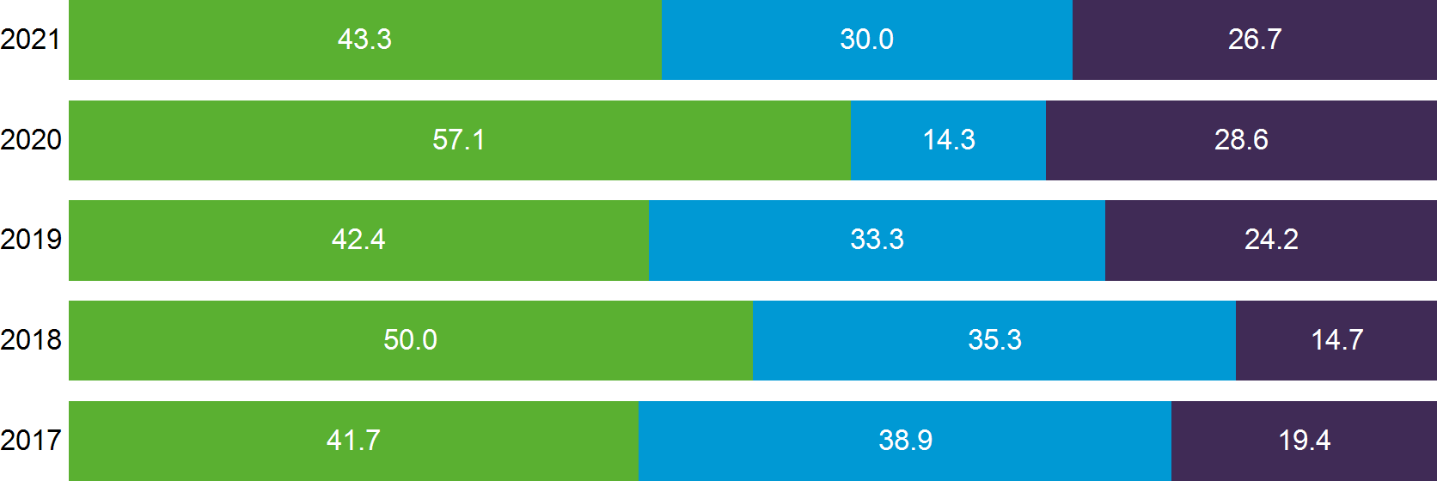

How does your school compare?

In education or training

In employment only

Not in education, employment or training

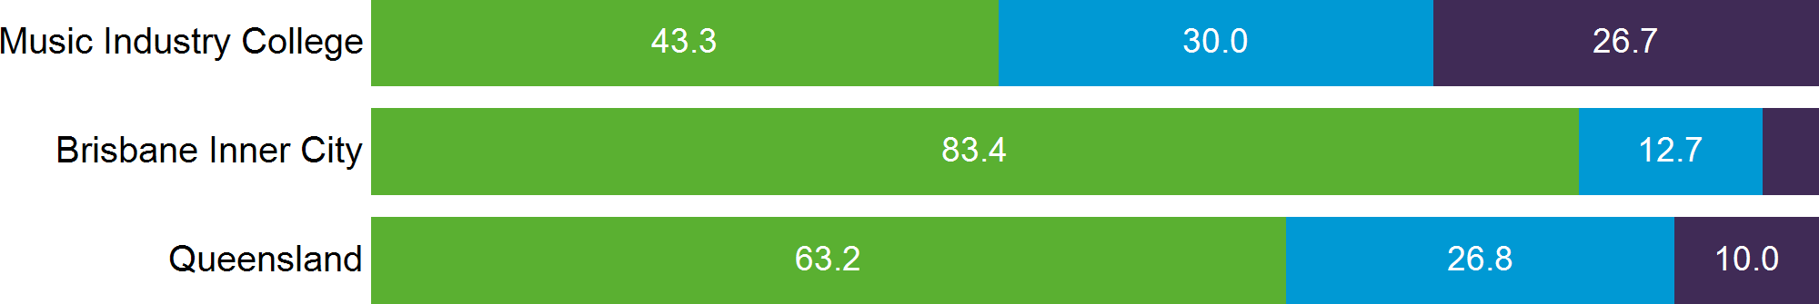

Main destination

Post-school destinations of survey respondents from Music Industry College in 2021.

All Year 12 completers were assigned to a main destination. This categorisation system prioritises education-related destinations over other destinations. For example, Year 12 completers who were both studying and working are reported as studying for their main destination (See Appendix 2).

23.3% of respondents deferred a tertiary offer and are reported in their current post-school destination in this report.

Main destination by gender

Main destination | Male | Female | Total
 | number | number | number | %
Bachelor Degree | 2 | 4 | 6 | 20.0

VET Certificate IV+ | 1 | 3 | 4 | 13.3
VET Certificate III | 0 | 1 | 1 | 3.3
VET Certificate I–II/other | 0 | 0 | 0 | 0.0
Apprenticeship | 0 | 0 | 0 | 0.0
Traineeship | 0 | 2 | 2 | 6.7
Full-time employment | 0 | 0 | 0 | 0.0
Part-time employment | 7 | 2 | 9 | 30.0
Seeking work | 3 | 4 | 7 | 23.3
NILFET* | 1 | 0 | 1 | 3.3
Total | 14 | 16 | 30 | 100.0
*NILFET: Not in the labour force, education or training.

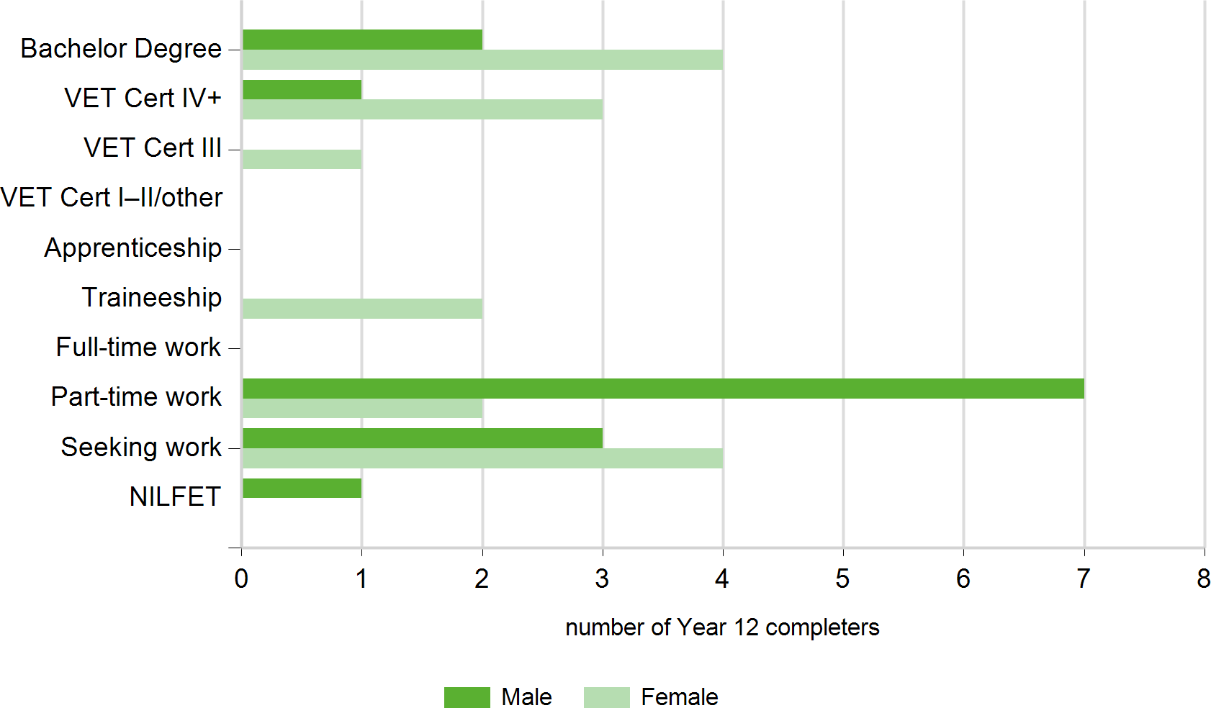

Main destinations over time

Main destination | 2017 |  | 2018 |  | 2019 |  | 2020 |  | 2021
 | no. | % | no. | % | no. | % | no. | % | no. | %
Bachelor Degree | 10 | 27.8 | 10 | 29.4 | 10 | 30.3 | 13 | 46.4 | 6 | 20.0

VET Certificate IV+ | 1 | 2.8 | 2 | 5.9 | 1 | 3.0 | 1 | 3.6 | 4 | 13.3
VET Certificate III | 2 | 5.6 | 2 | 5.9 | 2 | 6.1 | 2 | 7.1 | 1 | 3.3
VET Certificate I–II/other | 1 | 2.8 | 2 | 5.9 | 0 | 0.0 | 0 | 0.0 | 0 | 0.0
Apprenticeship | 1 | 2.8 | 0 | 0.0 | 1 | 3.0 | 0 | 0.0 | 0 | 0.0
Traineeship | 0 | 0.0 | 1 | 2.9 | 0 | 0.0 | 0 | 0.0 | 2 | 6.7
Full-time employment | 7 | 19.4 | 3 | 8.8 | 3 | 9.1 | 0 | 0.0 | 0 | 0.0
Part-time employment | 7 | 19.4 | 9 | 26.5 | 8 | 24.2 | 4 | 14.3 | 9 | 30.0
Seeking work | 4 | 11.1 | 5 | 14.7 | 8 | 24.2 | 2 | 7.1 | 7 | 23.3
NILFET | 3 | 8.3 | 0 | 0.0 | 0 | 0.0 | 6 | 21.4 | 1 | 3.3

Total | 36 | 100.0 | 34 | 100.0 | 33 | 100.0 | 28 | 100.0 | 30 | 100.0

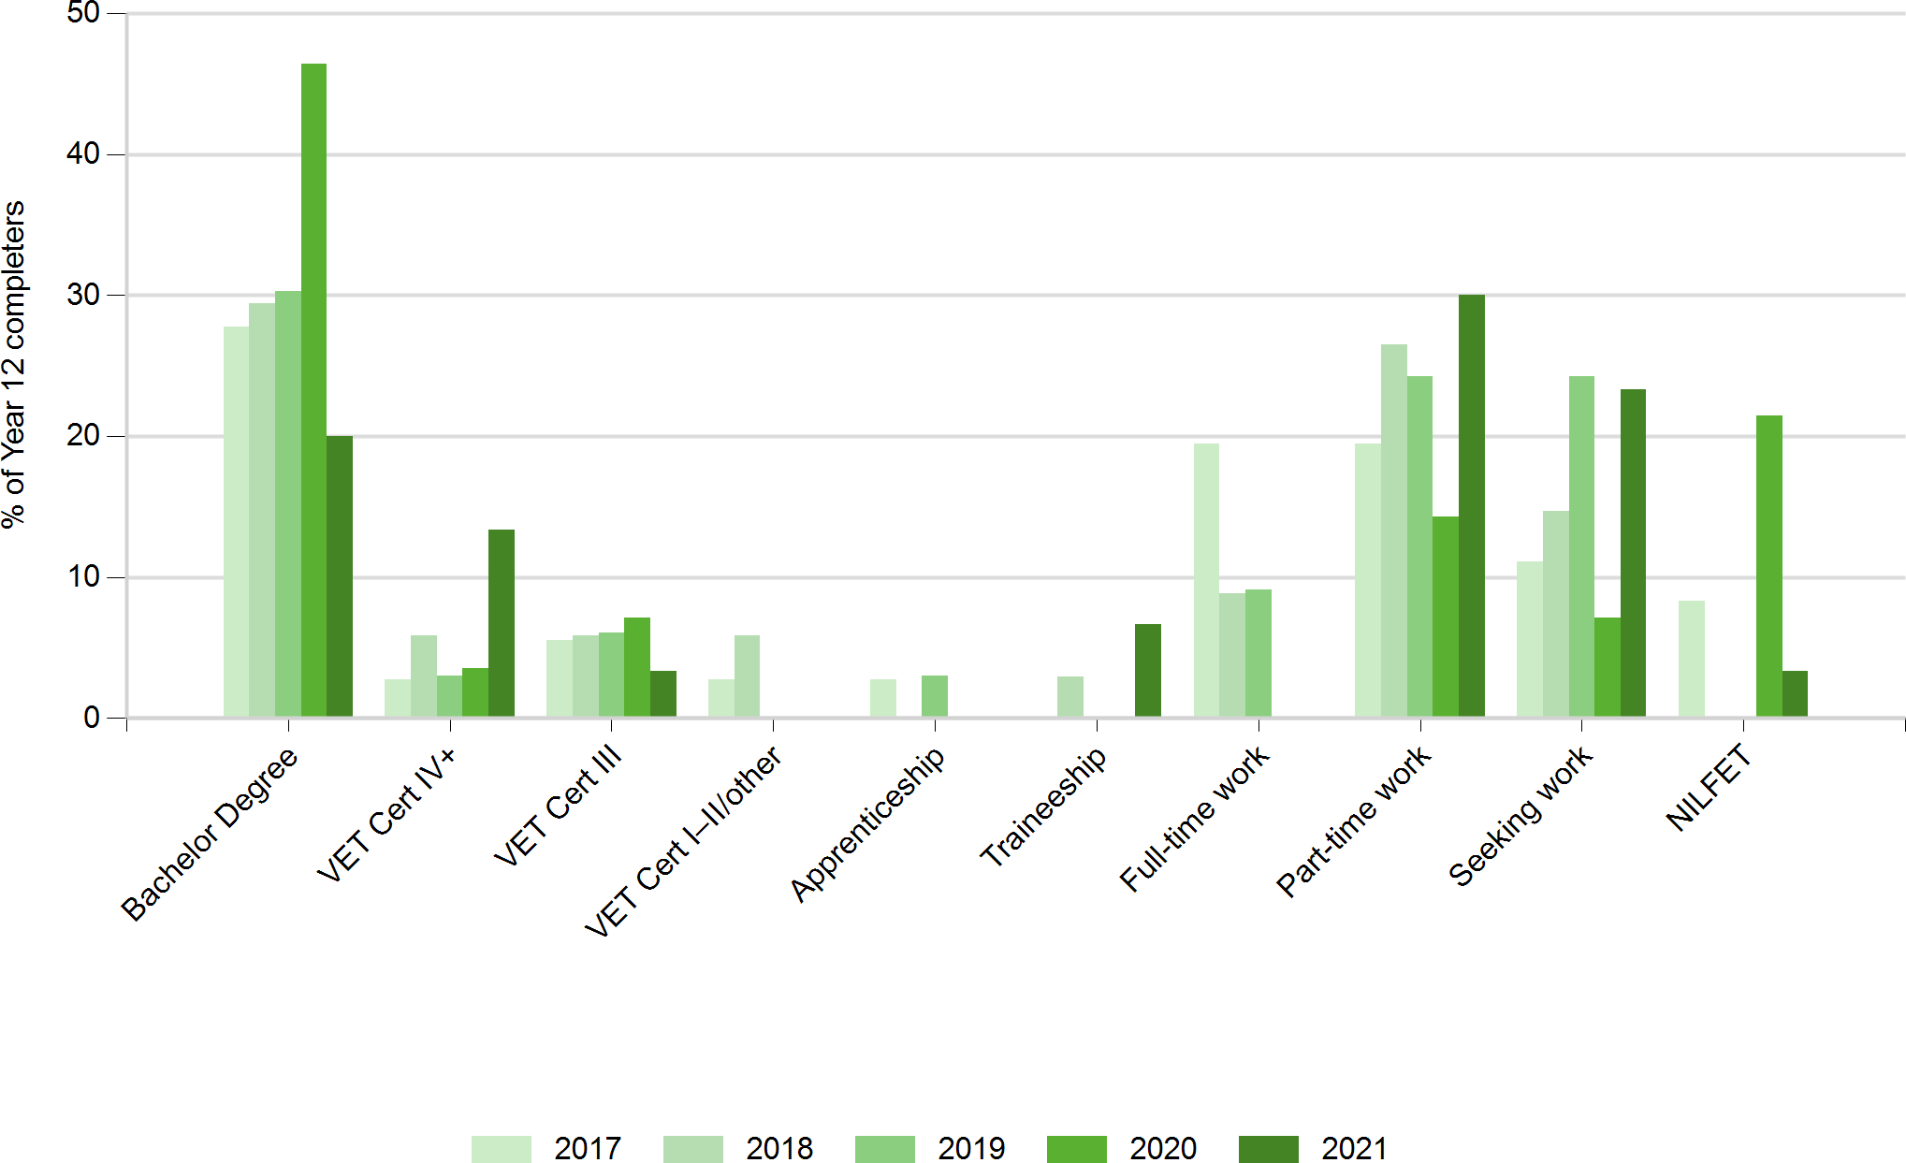

Main destinations of subgroups

Main destination for students who completed a VET qualification in school (VETiS)
There were 17 respondents who completed a VETiS.
Main destination | VETiS | non-VETiS | Total
 | number | number | number | %
Bachelor Degree | 3 | 3 | 6 | 20.0

VET Certificate IV+ | 2 | 2 | 4 | 13.3
VET Certificate III | 1 | 0 | 1 | 3.3
VET Certificate I–II/other | 0 | 0 | 0 | 0.0
Apprenticeship | 0 | 0 | 0 | 0.0
Traineeship | 1 | 1 | 2 | 6.7
Full-time employment | 0 | 0 | 0 | 0.0
Part-time employment | 5 | 4 | 9 | 30.0
Seeking work | 4 | 3 | 7 | 23.3
NILFET | 1 | 0 | 1 | 3.3
Total | 17 | 13 | 30 | 100.0

Main destination for students who participated in a school-based apprenticeship or traineeship (SAT)
There were 4 respondents who participated in a SAT.
Main destination | SAT | non-SAT | Total
 | number | number | number | %
Bachelor Degree | 1 | 5 | 6 | 20.0

VET Certificate IV+ | 0 | 4 | 4 | 13.3
VET Certificate III | 0 | 1 | 1 | 3.3
VET Certificate I–II/other | 0 | 0 | 0 | 0.0
Apprenticeship | 0 | 0 | 0 | 0.0
Traineeship | 1 | 1 | 2 | 6.7
Full-time employment | 0 | 0 | 0 | 0.0
Part-time employment | 0 | 9 | 9 | 30.0
Seeking work | 1 | 6 | 7 | 23.3
NILFET | 1 | 0 | 1 | 3.3
Total | 4 | 26 | 30 | 100.0

Main destination for students who received an Australian Tertiary Admission Rank (ATAR)or International Baccalaureate Diploma (IBD)
There were 16 respondents who received an ATAR or IBD.
Main destination | ATAR or IBD | Not ATAR or IBD | Total
 | number | number | number | %
Bachelor Degree | 5 | 1 | 6 | 20.0

VET Certificate IV+ | 2 | 2 | 4 | 13.3
VET Certificate III | 0 | 1 | 1 | 3.3
VET Certificate I–II/other | 0 | 0 | 0 | 0.0
Apprenticeship | 0 | 0 | 0 | 0.0
Traineeship | 0 | 2 | 2 | 6.7
Full-time employment | 0 | 0 | 0 | 0.0
Part-time employment | 5 | 4 | 9 | 30.0
Seeking work | 3 | 4 | 7 | 23.3
NILFET | 1 | 0 | 1 | 3.3
Total | 16 | 14 | 30 | 100.0

Main destination for Aboriginal and Torres Strait Islander students
There were no respondents who identified as an Aboriginal and Torres Strait Islander person.

Education and training

This section examines the education and training destinations and includes Bachelor Degree, VET Certificate IV+, VET Certificate III, VET Certificate I-II/other, Apprenticeship and Traineeship main destinations.

13 out of 30 Year 12 completers from Music Industry College continued in education or training in 2021.
43.3%

1 Year 12 completers from Music Industry College were enrolled in a double degree, combining two bachelor degrees into a single course of study.
3.3%

What are they studying?

Study field (broad) by gender

Study field | Male | Female | Total
 | number | number | number
Creative Arts | 2 | 4 | 6

Management And Commerce | 0 | 2 | 2
Society And Culture | 0 | 2 | 2
Information Technology | 1 | 0 | 1
Health | 0 | 1 | 1
Other | 0 | 1 | 1
Total | 3 | 10 | 13
Field of study categories based on the Australian Standard Classification of Education.

Study field (broad) by level of study
Study field | Bachelor Degree | Other | Total
 | number | number | number
Creative Arts | 4 | 2 | 6
Management And Commerce | 0 | 2 | 2
Society And Culture | 1 | 1 | 2
Information Technology | 0 | 1 | 1
Health | 1 | 0 | 1
Other | 0 | 1 | 1
Total | 6 | 7 | 13
Field of study categories based on the Australian Standard Classification of Education.
Bachelor Degree includes Bachelor Degree, Bachelor (Honours) Degree, Master Degree and Doctoral Degree, in addition to apprentices and trainees who said they were studying at one of these levels of study.
Other includes Associate Degree, Advanced Diploma, Diploma, VET Certificate levels I - IV and unknown level of study.

Study field (narrow) by gender
Study field* | Male | Female | Total
 | number | number | number
Performing Arts | 1 | 1 | 2
Visual Arts and Crafts | 1 | 1 | 2
Communication and Media Studies | 0 | 2 | 2
Computer Science | 1 | 0 | 1
Business and Management | 0 | 1 | 1
Justice and Law Enforcement | 0 | 1 | 1
Medical Studies | 0 | 1 | 1
Office Studies | 0 | 1 | 1
Other Health | 0 | 1 | 1
Other Society and Culture | 0 | 1 | 1

Other | 0 | 1 | 1
Total (students) | 3 | ** 10 | ** 13
Field of study categories based on the Australian Standard Classification of Education.
*Both fields of study have been included for 1 student enrolled in a double degree in more than one narrow field.
**Total number of students is less than combined total of all study fields.

Study field (narrow) by level of study
Study field* | Bachelor Degree | Other | Total
 | number | number | number
Performing Arts | 2 | 0 | 2

Visual Arts and Crafts | 1 | 1 | 2
Communication and Media Studies | 1 | 1 | 2
Computer Science | 0 | 1 | 1
Business and Management | 0 | 1 | 1
Justice and Law Enforcement | 1 | 0 | 1
Medical Studies | 1 | 0 | 1
Office Studies | 0 | 1 | 1
Other Health | 1 | 0 | 1
Other Society and Culture | 0 | 1 | 1

Other | 0 | 1 | 1
Total (students) | ** 6 | 7 | ** 13
Field of study categories based on the Australian Standard Classification of Education.
Bachelor Degree includes Bachelor Degree, Bachelor (Honours) Degree, Master Degree and Doctoral Degree, in addition to apprentices and trainees who said they were studying at one of these levels of study.
Other includes Associate Degree, Advanced Diploma, Diploma, VET Certificate levels I - IV and unknown level of study.
*Both fields of study have been included for 1 student enrolled in a double degree in more than one narrow field.
**Total number of students is less than combined total of all study fields.

Where are they studying?
Study institution by gender
Institution name | Male | Female | Total
 | number | number | number
TAFE Queensland Greater Brisbane | 0 | 3 | 3

Queensland University of Technology | 1 | 1 | 2
Interstate university | 1 | 0 | 1
JMC Academy | 1 | 0 | 1
Australian Catholic University | 0 | 1 | 1
Griffith University | 0 | 1 | 1
Other private training college | 0 | 1 | 1
Other/Unspecified Queensland TAFE | 0 | 1 | 1
SAE (Qantm College) | 0 | 1 | 1
University of Southern Queensland | 0 | 1 | 1
Total | 3 | 10 | 13
How are they studying?

46.2%
studying at university

61.5%
studying
full-time

61.5%
combining study with
paid employment

Employment (total)

This section examines the labour market outcomes for Year 12 completers from Music Industry College.

56.7%

17 out of 30 Year 12 completers were in paid employment in 2021. This figure includes 9 who were only working and 8 who were both working and studying.

What jobs are they doing?

Occupation by gender

Occupational unit group | Male | Female | Total
 | number | number | number
Delivery Drivers | 2 | 0 | 2

Bar Attendants and Baristas | 1 | 1 | 2
Waiters | 1 | 1 | 2
Sales Assistants (General) | 0 | 2 | 2
Amusement, Fitness and Sports Centre Managers | 1 | 0 | 1
Checkout Operators and Office Cashiers | 1 | 0 | 1
Other Factory Process Workers | 1 | 0 | 1
Shelf Fillers | 1 | 0 | 1
Cooks | 0 | 1 | 1
Court and Legal Clerks | 0 | 1 | 1
Kitchenhands | 0 | 1 | 1
Other Clerical and Office Support Workers | 0 | 1 | 1

Other Hospitality Workers | 0 | 1 | 1
Total | 8 | 9 | 17
Occupation category based on the Australian and New Zealand Standard Classification of Occupations.Total

What industry are they working in?

Industry by gender
Industry | Male | Female | Total
 | number | number | number
Accommodation & Food Services | 3 | 7 | 10
Arts & Recreation Services | 2 | 1 | 3
Retail Trade | 2 | 0 | 2
Manufacturing | 1 | 0 | 1

Professional, Scientific & Technical Services | 0 | 1 | 1
Total | 8 | 9 | 17
Industry categories are based on the Australian and New Zealand Standard Industrial Classification (ANZSIC).Total

How are they working?

23.5%
working
full-time

47.1%
combining work
with further study

70.6%
employed on a
casual basis

Not in Education, Employment, or Training (NEET)

This section examines the reasons why Year 12 completers from Music Industry College were not engaged in education, employment or training.

26.7%
8 out of 30 Year 12 completers were not engaged in education, employment or training at the time of the survey.

Why are they not studying?
Main reason for not studying

Main reason | Total
 | number
Health reasons | 2
Waiting for course/training to begin | 2
Wanted a break from study | 2
Not interested in further study/already finished studying | 1

Don't feel ready for study at the moment | 1
Total | 8

Have they had work since school?

5 out of 8 Year 12 completers were not working or studying at the time of the survey, but had paid employment at some time since finishing school.
62.5%

Main reason for stopping previous job

Main reason | Total
 | number
Not satisfied with the job | 2
Got laid off/sacked 1
1
Health reasons
I turned 18 - younger workers are cheaper 1
Total
5

Are they seeking work?
7 out of 8 Year 12 completers were not working or studying at the time of the survey, but were seeking work.
87.5%

Main reason unsuccessful getting a job

Main reason | Total
 | number
Not enough job experience | 2
Not trying very hard | 2
Only just started looking for job | 1
Aren't enough jobs available | 1

I turned 18 - younger workers are cheaper | 1
Total | 7

Why are they not seeking work?
1 out of 8 Year 12 completers was not working or studying at the time of the survey and was not seeking work, also known as NILFET.
12.5%

Main reason not looking for a job

Main reason | Total
 | number
Future study commitments | 1
Total | 1

Where to from here?

50.0%
taking a
gap year

25.0%
deferred a place at university

25.0%
waiting for work or study to commence

Appendices

Appendix 1 – Acronyms and initialisms
ATAR Australian Tertiary Admission Rank DW Data withheld
IBD International Baccalaureate Diploma NA Not applicable
NILFET Not in the labour force, education or training SAT School-based apprenticeships and traineeships TAFE Technical and further education
VET Vocational Education and Training

Appendix 2 – Explanatory notes

Main destination
A structured hierarchy of study and labour force destinations for Year 12 completers, who were assigned to categories as follows:
- students were assigned to the relevant higher education or VET category, even if they were also employed
- apprentices and trainees were assigned to their respective category and classified as education and training since their training involves study
- those assigned to a labour force category (employed or seeking work) were not also undertaking study
- those who were not studying and not in the labour force (not employed and not seeking work) were categorised as NILFET.

Main destination categories
Education and training – higher education
Bachelor Degree* Studying at Bachelor Degree level (including Honours), or higher.
Education and training – VET categories
VET Certificate IV+* Studying at Certificate IV, Diploma, Advanced Diploma or Associate
Degree level (excluding apprentices and trainees).
VET Certificate III* Studying at Certificate III level (excluding apprentices and trainees). VET Certificate I–II/other* Studying at Certificate I or II level (excluding apprentices and trainees).
This category also includes students in an unspecified VET course, other basic course (e.g. short course) and unknown course level.

Apprenticeship* Employment-based apprenticeship.

Traineeship* Employment-based traineeship.
Employment
Full-time employment Working full-time (35 hours or more per week) and not in an education or
training category. This includes people with multiple part-time or casual jobs that total 35 hours or more.

Part-time employment Working part-time or casual (fewer than 35 hours per week) and not in an
education or training category.
Not in education, employment or training (NEET)
Seeking work Looking for work and not in an education or training category.

NILFET Not in education or training, not working and not seeking work.
*Some respondents may also be in employment or seeking work.

More information
For more information about terms and categorisations used in this report, view the research method section of the Next Step website www.qld.gov.au/nextstep

